**Analytic Vidya – Job A Thon May 2021**

**Problem Statement:**

**Credit Card Lead Prediction**

Happy Customer Bank is a mid-sized private bank that deals in all kinds of banking products, like Savings accounts, Current accounts, investment products, credit products, among other offerings.

The bank also cross-sells products to its existing customers and to do so they use different kinds of communication like tele-calling, e-mails, recommendations on net banking, mobile banking, etc.

In this case, the Happy Customer Bank wants to cross sell its credit cards to its existing customers. The bank has identified a set of customers that are eligible for taking these credit cards.

Now, the bank is looking for your help in identifying customers that could show higher intent towards a recommended credit card, given:

* Customer details (gender, age, region etc.)
* Details of his/her relationship with the bank (Channel_Code , Vintage, 'Avg_Asset_Value etc.)

## ****Data Dictionary****

|  |  |
| --- | --- |
| Variable | Definition |
| ID | Unique Identifier for a row |
| Gender | Gender of the Customer |
| Age | Age of the Customer (in Years) |
| Region_Code | Code of the Region for the customers |
| Occupation | Occupation Type for the customer |
| Channel_Code | Acquisition Channel Code for the Customer  (Encoded) |
| Vintage | Vintage for the Customer (In Months) |
| Credit_Product | If the Customer has any active credit product (Home loan,  Personal loan, Credit Card etc.) |
| Avg_Account_Balance | Average Account Balance for the Customer in last 12 Months |
| Is_Active | If the Customer is Active in last 3 Months |
| Is_Lead(Target) | If the Customer is interested for the Credit Card |

**Solution Approach:**

**Exploratory Data Analysis:**

**1)Shape of Dataset**

Train dataset : (245725, 11)

Test dataset : (105312, 10)

**2) Datatype of dataset:**

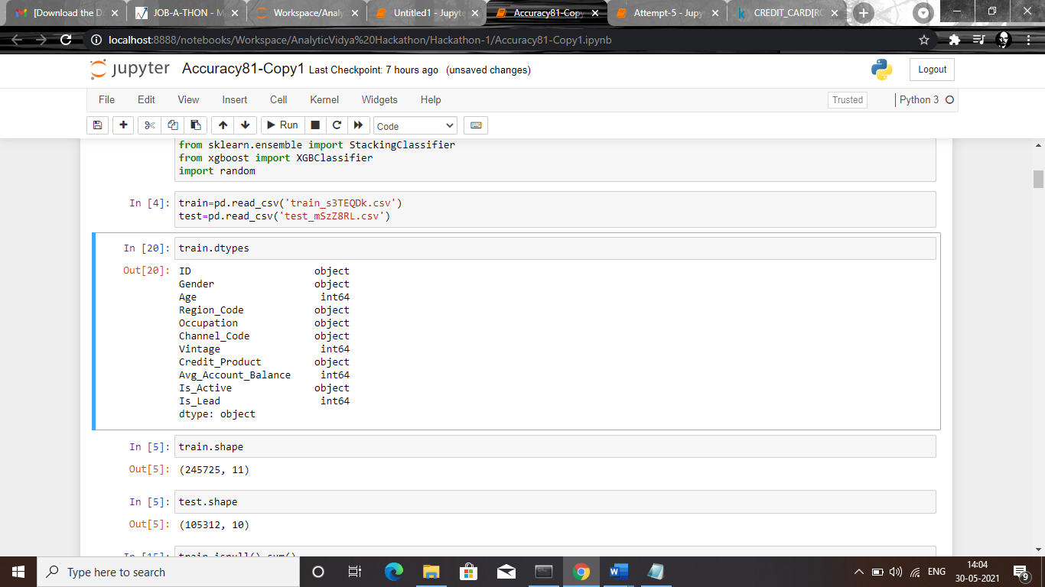

**3)Checking for Duplicate values in Test and Train dataset:**

Duplicate value is not available in test as well train dataset.

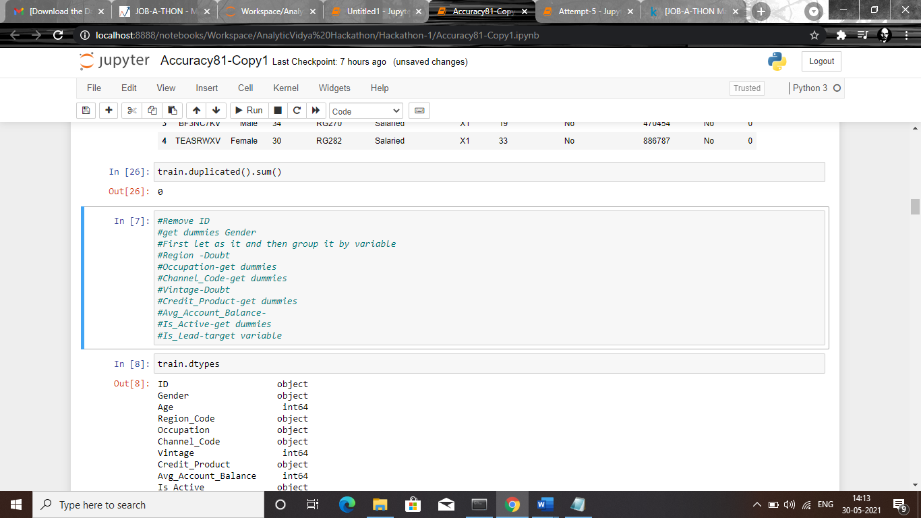

**4)Checking for null values in the dataset:**

**Train Set:**

Null values present in feature **Credit_Product.** which has **11.9%** [29325] of missing value.

**Test Set:**

Null values present in feature **Credit_Product.** which has **11.8%** [12522] of missing value**.**

For handling the Null values, we were imputing the null values with the value **‘Yes’** in both train and test data set.

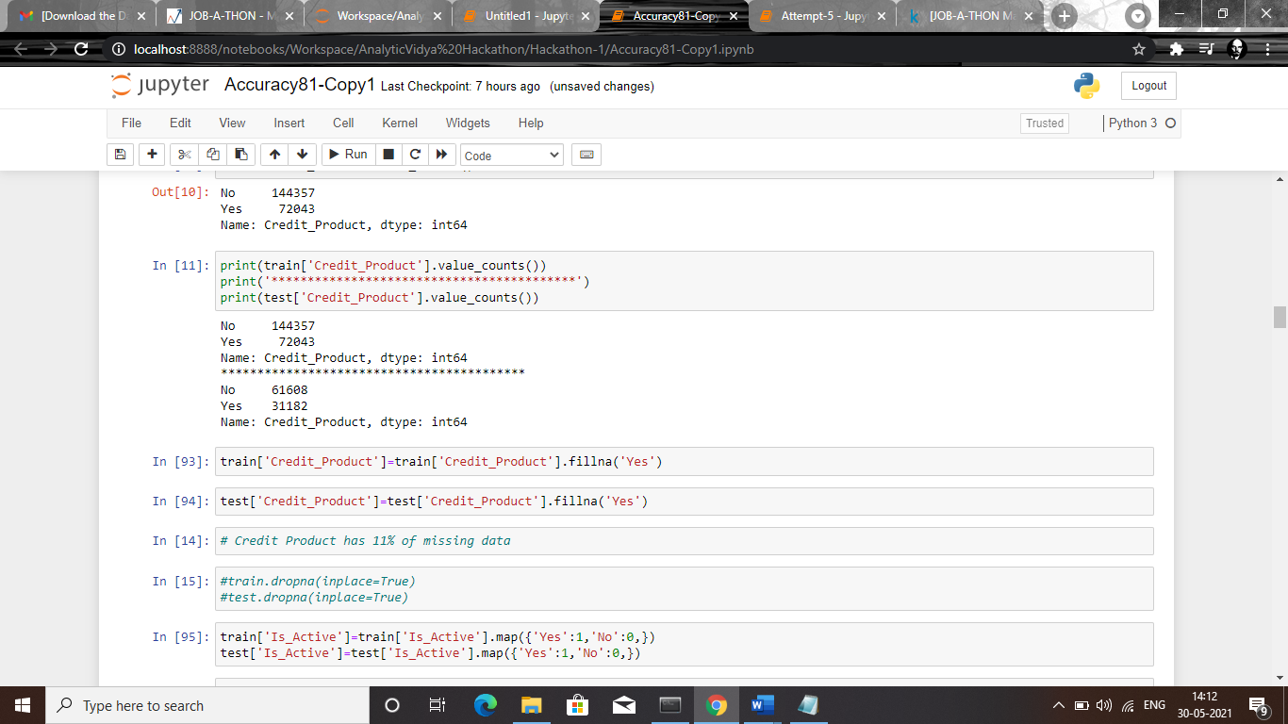

**5) Handling Outliers:**

We observed that feature [**Avg_Account_Balance**] is highly right Skewed. So we apply log transformation method to normalize the feature.

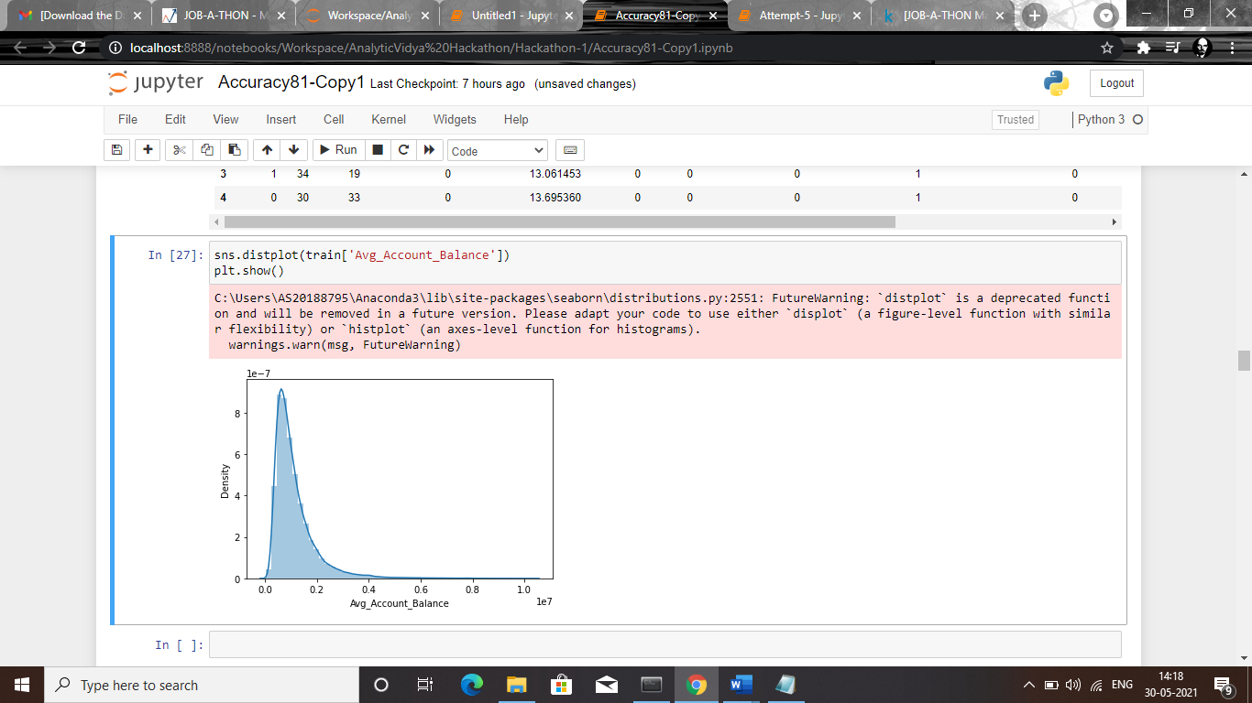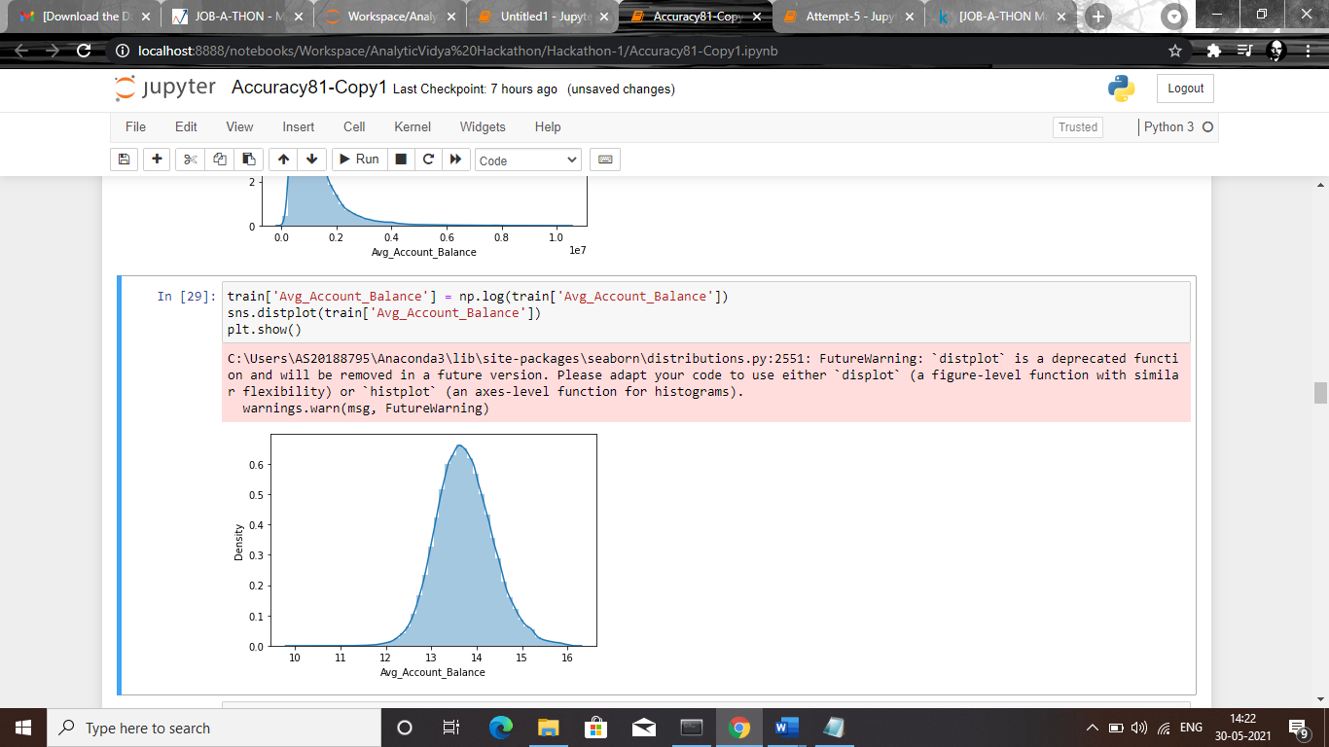

**6) Encoding Categorical features:**

We were using Label Encoder method to encode features having more than two categories.

**7) Checking Multicollinearity:**

Here we observed thers is no high corelation among the features

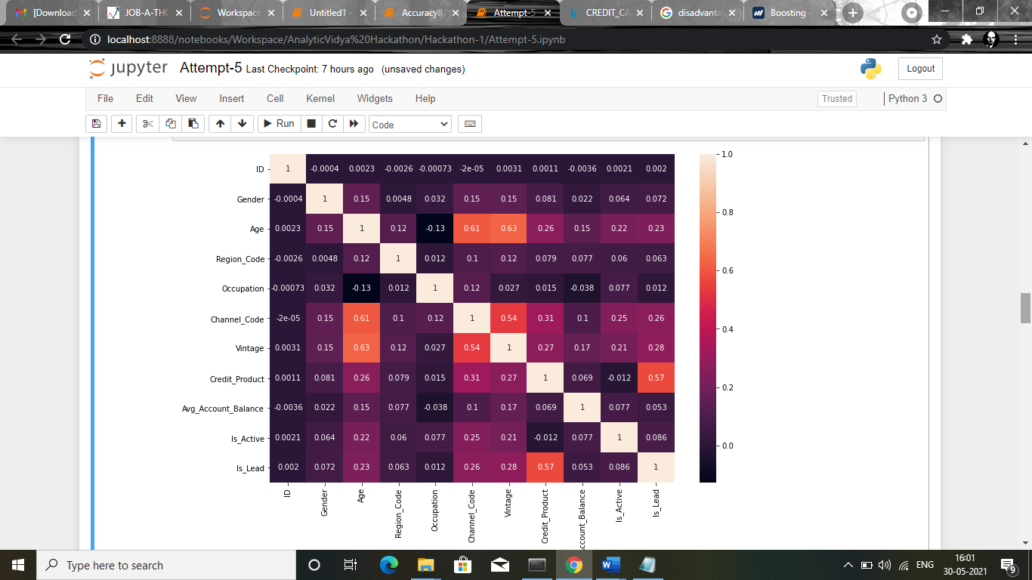

**Note:**

Our target variable in the dataset is highly imbalanced.

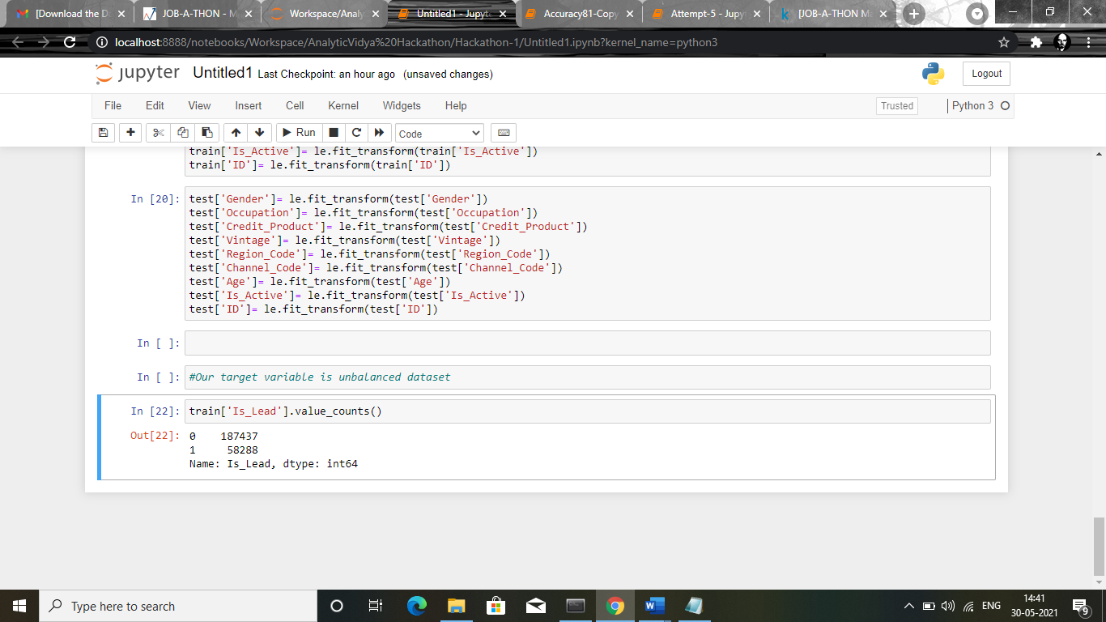

**Modelling Technique:**

1. **Logistic Regression :**

Here we used Based model as Logistic Regression model.Which is a statistical model that in its basic form uses Logistic function, also known as sigmoid function to model the binary dependent variable.

**Classification Report:**

|  |  |  |  |
| --- | --- | --- | --- |
| Test Set | Precision | Recall | F1-Score |
| 0 | 0.77 | 0.94 | 0.85 |
| 1 | 0.31 | 0.12 | 0.18 |

**Confusion Matrix:**

|  |  |
| --- | --- |
| True Positive | 58037 |
| True Negative | 2225 |
| False Positive | 3732 |
| False Negative | 17096 |

**Accuracy: 0.7431495868787766**

Since , Our model is not performing well in False Negative/Positive rate and Accuracy rate is also not good.So we are going to test our model in other classification techniques and will select the model which performing well in our dataset and having high accuracy and AUC-ROC score.

1. **Stacking Classifier with Ada Boosting:**

As our model is a slow leaner ,so we were using boosting technique to convert our model to strong leaner.Here we were using ADA Boosting method as an estimator .

**Base learner for our model will be :**

1)Decision Tree clasifier

2) Random Forest Classifier

**Final Estimator:**

1)Ada Boosting Classifier

**AUC-Score:** 0.860068094

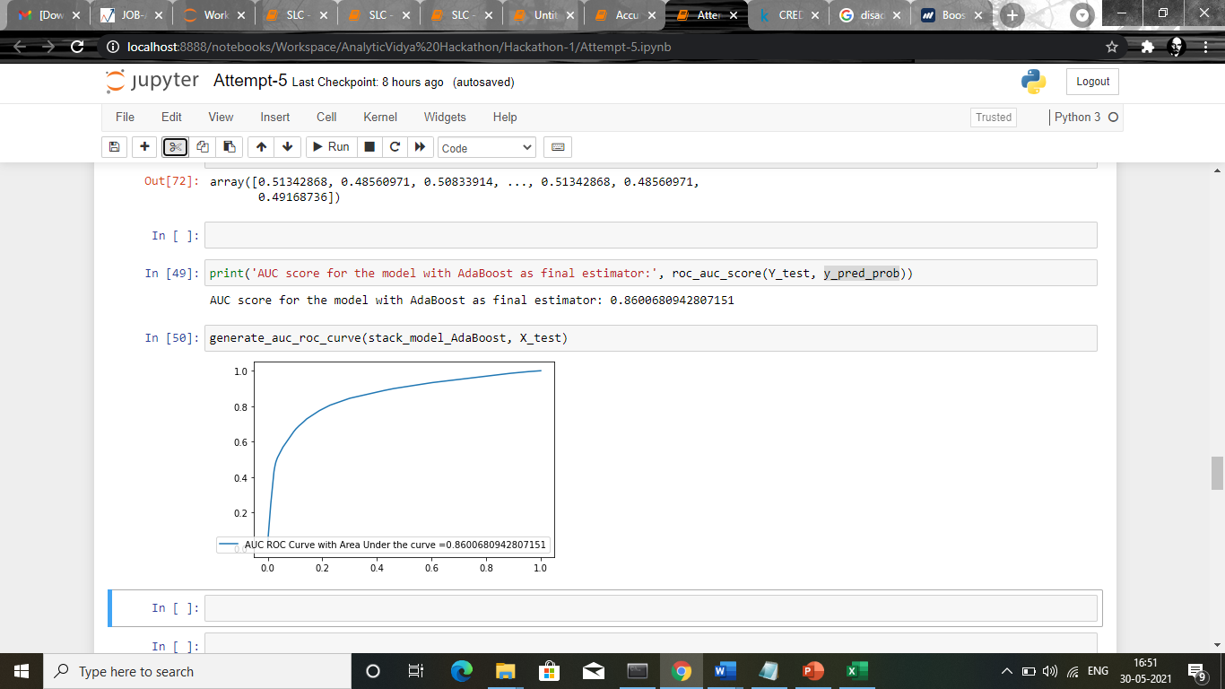

Using stacking classifier technique our model performed well and AUC-ROC score good compared to the logistic regression.We will compute further modelling with other techniques and choose the model with high accuracy / AUC-ROC score.

1. **Extreme Boost Classifier (XG Boost Classifier):**

[**XGBoost**](https://xgboost.ai/)is a decision-tree-based ensemble Machine Learning algorithm that uses a [gradient boosting](https://en.wikipedia.org/wiki/Gradient_boosting) framework. XGBoost is fast. Really fast when compared to other implementations of gradient boosting.

**Classification Report:**

|  |  |
| --- | --- |
| Accuracy | 0.85911 |
| Precision | 0.79194 |
| Recall | 0.55437 |
| F1-Score | 0.65219 |

**Confusion Matrix:**

|  |  |
| --- | --- |
| True Positive | 58955 |
| True Negative | 10711 |
| False Positive | 2814 |
| False Negative | 8610 |

**ROC-AUC Score:**

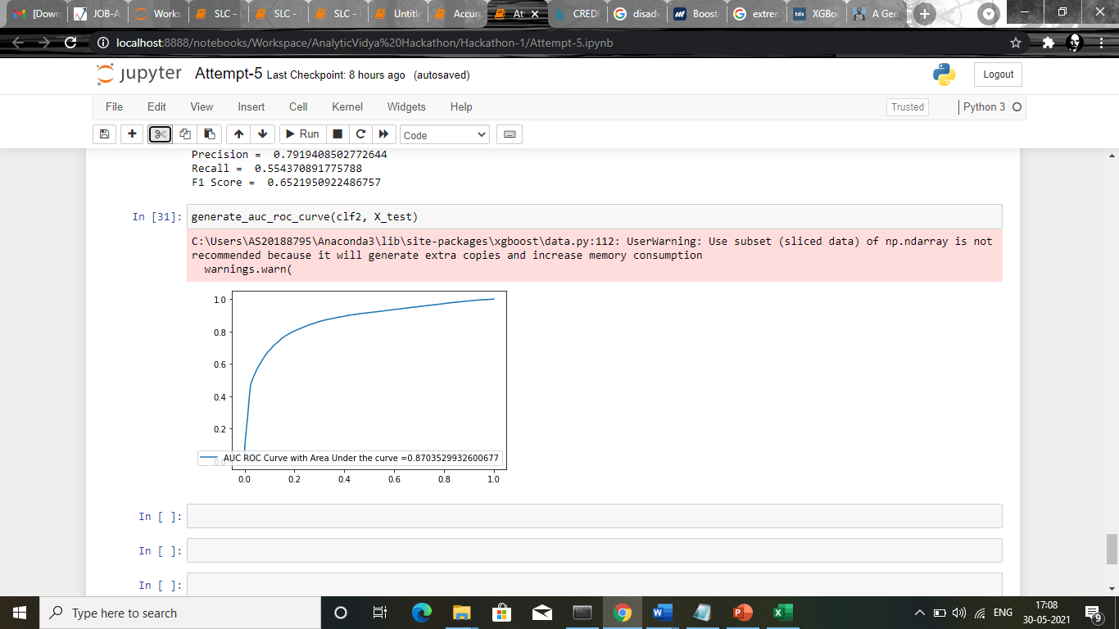

**AUC-ROC Score: 0.8703**

**Model Comparision :**

**Scores Comparision Logistic Regression vs XGBoost technique:**

|  |  |  |
| --- | --- | --- |
| Metrics | Logistic Regression | XG Boost |
| True Positive | 58037 | 58955 |
| True Negative | 2225 | 10711 |
| False Positive | 3732 | 2814 |
| False Negative | 17096 | 8610 |
| ROC-AUC Score | 0.74 | 0.87 |

In XG boost, False Negative rate is drastically less than the logistic regression and accuracy score also high compared to logistic model.

**Classification Report for Logistic Regression:**

|  |  |  |  |
| --- | --- | --- | --- |
| Test Set | Precision | Recall | F1-Score |
| 0 | 0.77 | 0.94 | 0.85 |
| 1 | 0.31 | 0.12 | 0.18 |

**Classification Report for XG Boost:**

|  |  |  |  |
| --- | --- | --- | --- |
| Test Set | Precision | Recall | F1-Score |
| 0 | 0.87 | 0.95 | 0.91 |
| 1 | 0.79 | 0.55 | 0.65 |

In classification report Precision,Recall, F1 score is comparatively high than logistic model.

**Conclusion :**

From the above comparisons **Extreme Gradient boosting** perform well in our dataset.So in our model we had used XG Boosting model for predicting the target feature and the performance of the model is good in test data with an accuracy of **0.8703.**